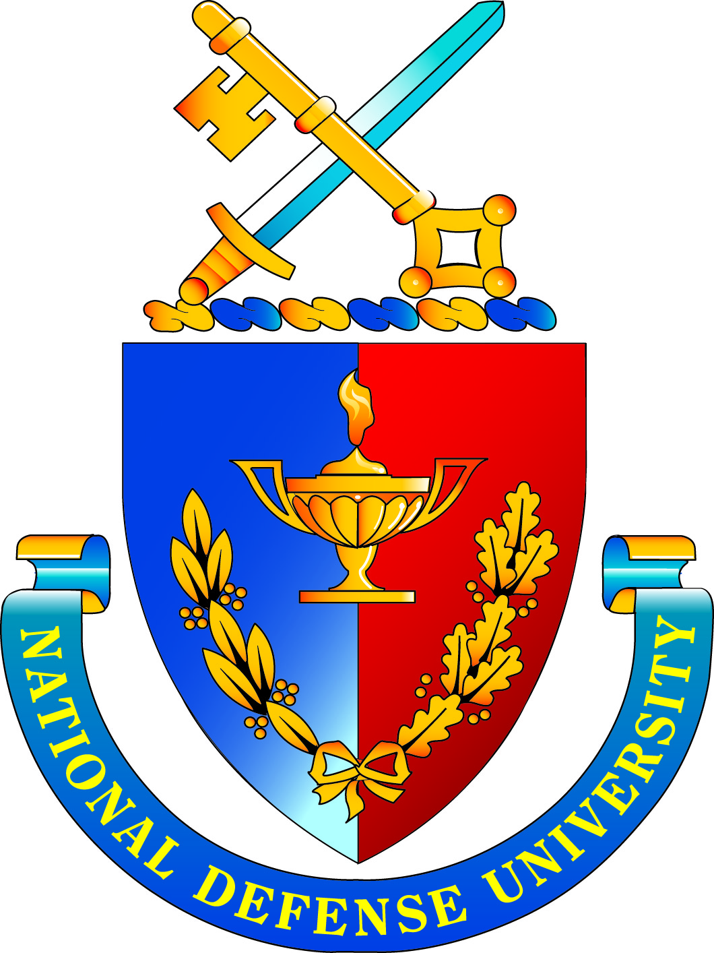 | National Defense University  Board of Visitors Meeting  July 11-12, 2017  AGENDA
Military: Class A Uniform
Civilian: Business Suit

Tuesday, 11 July 2017
Room 155A/B, Marshall Hall

1300 Call to Order Colonel Richard Cabrey, USA
(Retired), Designated Federal
Officer

1300-1315 Administrative Notes Colonel Cabrey; General Lloyd (DFO comments/overview of agenda) “Fig” Newton, USAF (Retired), BOV Chair

1315-1345 Video and State of the University Address Major General Frederick M. Padilla NDU President

1345-1430 State of the NDU Budget Major General Robert Kane,
USAF (Retired), Chief Operating
Officer; Mr. Jay Helming, Chief
Financial Officer

1430-1500 Review of the Process for the Accreditation of Dr. John Yaeger, NDU Provost
Joint Education (PAJE) Visits for NDU Programs

1500-1515 BREAK

1515-1615 College Value Propositions Rear Admiral Janice Hamby, USN
(Ret), Chancellor, College of
Information and Cyberspace;
Colonel Ann Knabe, Dean of Students, College of International
Security Affairs; Rear Admiral Jeffrey Ruth, Commandant, Joint
Forces Staff College; Brigadier
General Chad Manske,
Commandant, National War
College; Brigadier General Paul
Fredenburgh III, Commandant, The
Eisenhower School

1615-1630 Industry Fellows Recruitment Strategy Brigadier General Fredenburgh III

1630-1645 Day One Wrap Up General Newton and Major General
Padilla

1645 Meeting Ends for the Day Colonel Cabrey

Wednesday, 12 July 2017
Room 155A/B, Marshall Hall

0830 Call to Order Colonel Cabrey

0830-0915 Information Technology/Academic Technology Rear Admiral Diane Webber, USN
Migration Progress Update (Retired), Chief Information
Officer

0915-0945 Cyber Curriculum Review Rear Admiral Hamby

0945-1015 Faculty and Staff Command Climate Survey Dr. B.J. Miller, NDU Director of
Results and Analysis Institutional Research, Planning and Assessment

1015-1030 Planning Process for Strategic Plan Dr. Yaeger and Major General
AY 2018-2019 to AY 2023-2024 Kane

1030-1045 BREAK

1045-1145 BOV Member Feedback Board Members

1145-1200 Wrap-up and Closing Remarks General Newton and Major General Padilla

